**Exercise 3 - Introduction To HTML and CSS**

Name - Aman Patel

ID - 3988

Email: aman.patel@tothenew.com

**How are inline and block elements different from each other?**

ANS: The *Block* elements start at the beginning of the line and take up the whole space to the last (of the immediate parent).

While the *Inline* elements are the one which take up only required space in the current block and the rest of the space is available for the next element to occupy.

**Explain the difference between visibility:hidden and display:none**.

ANS: In the *visibility:hidden* the element is not visible on the page but the required space is allocated to it.

While in *display:none* the element is not available for any kind of interation at all with or without DOM.

**Explain the clear and float properties.**

ANS: The *float* property specifies the portion where the element should float. Float enable even the block elements to allow other elements in the same line.

The *clear* property specifies where other elements are not allowed to float around the element given the property.

**Explain difference between absolute, relative,fixed and static.**

ANS:

***relative***: This positions the element relative to the normal or default positioning of the element. If we give an element the following CSS: *position: relative; left:5px; top:5px*, it will be shifted 5 pixels to the right and to the bottom from its normal position.

**absolute**: This positions the elements in the coordinates given by *left, right, top* and *bottom* inside the first parent with position property set to anything except static. If there's no such ancestor, it will be positioned inside the body element. For example, if we have a div inside another div, and the parent div has its *position* set to *relative*, if we give the inner div the following CSS: *position: absolute; left:5px; top:5px*, it will be positioned 5 pixels away from the top and left edges of the parent div. This is how floating panels are created in web pages.

**fixed**: Is the same as *absolute*, but the difference is that the element is positioned inside the viewport. The "viewport" is the rectangular area of a web page that your web browser displays at a time. For example, if we give an element the following CSS: *position: fixed; left:5px; top:5px*, it will be positioned 5 pixels away from the top and left of the viewport and will always be there irrelevant to our scrolling position.

**static**: Is the default behaviour, which means that the browser positions the element as its appearance in the HTML document and the normal flow dictates. The left, right, top, bottom are ignored in this case.

**Write the HTML code to create a table in which there are 4 columns( ID , Employee Name, Designation, Department) and at least 6 rows. Also do some styling to it.**

ANS:

<!DOCTYPE *html*>

<html>

<head>

<style>

table {

border-collapse: collapse;

width: 100%;

}

th, td {

text-align: left;

padding: 8px;

}

th {

background-color: rgb(55, 182, 182);

color: white;

}

tr*:nth-child*(even) {background-color: #f2f2f2;}

</style>

</head>

<body>

<div *style*="overflow-x:auto;">

<table>

<tr>

<th>ID</th>

<th>Employee Name</th>

<th>Designation</th>

<th>Department</th>

</tr>

<tr>

<td>TTN-101</td>

<td>A</td>

<td>Engineer</td>

<td>Technical</td>

</tr>

<tr>

<td>TTN-102</td>

<td>B</td>

<td>Assistant</td>

<td>Business</td>

</tr>

<tr>

<td>TTN-103</td>

<td>C</td>

<td>Manager</td>

<td>HR</td>

</tr>

<tr>

<td>TTN-104</td>

<td>D</td>

<td>Executive</td>

<td>Technical</td>

</tr>

<tr>

<td>TTN-105</td>

<td>E</td>

<td>Engineer</td>

<td>Business</td>

</tr>

<tr>

<td>TTN-106</td>

<td>F</td>

<td>Engineer</td>

<td>HR</td>

</tr>

</table>

</div>

</body>

</html>

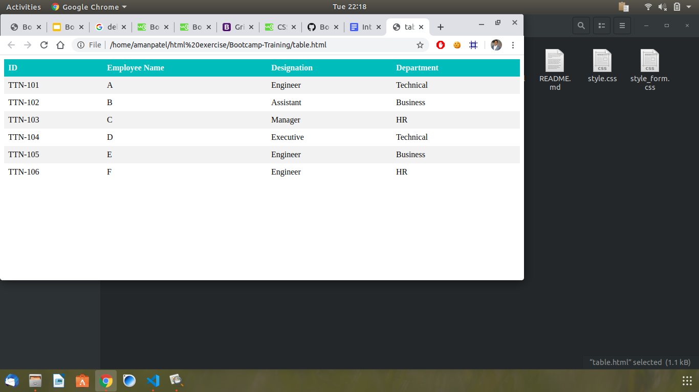

**Why do we use meta tags?**

The **meta** tags contain the metadata in which the contents are not shown on the web page but the contents are there for the machine to use. Several web services and data about the page or keywords can be provided in the meta tag.

**Explain Box Model.**

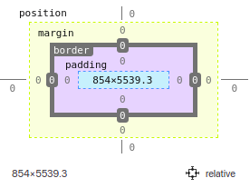

The box mode in CSS is a box-like structure that is present around every HTML element on the page. Margins, borders, padding, and the actual content are the components of the box model.

* Content is the main part which has text and images or other elements.
* The padding is transparent and it clears the area around the elements that are inside by pushing them within.
* Border is an enclosing styled or unstyled that surrounds the elements.
* It pushes the elements outside it to clear the area, it is transparent.

**What are the different types of CSS Selectors?**

ANS: There are five types of CSS Selectors.

* Element Selector: It selects the element based on the tag name.
* Id Selector: It selects the elements based on the id given to it.
* Class Selector: It selects based on the Class name given to the element. Class Selector for specific elements can be used to target only one element of a class using these.
* Universal Selector: An asterix can be used to target all the elements on the page.
* Group Selector: We can put element or class or id names comma separated to target specific groups.

**Define Doctype.**

ANS: The <!DOCTYPE> declaration is the very first thing in the HTML document, before the <html> tag. The <!DOCTYPE> declaration is not an HTML tag; it is an instruction to the web browser about what version of HTML the page is written in.

**Explain 5 HTML5 semantic tags.**

ANS:

<article>:

The <article> element specifies independent, self-contained content. An article should make sense on its own, and it should be possible to read it independently from the rest of the web site.

<figcaption>:

It defines the caption of an image.

<footer>:

The <footer> element specifies a footer for a document or section. A <footer> element should contain information about its containing element. A footer typically contains the author of the document, copyright information, links to terms of use, contact information, etc. You may have several <footer> elements in one document.

<header>:

The <header> element specifies a header for a document or section. The <header> element should be used as a container for introductory content. You can have several <header> elements in one document.

<nav>:

The <nav> element defines a set of navigation links.

**Create HTML for web-page.jpg (check resources, highest weightage for answers).**

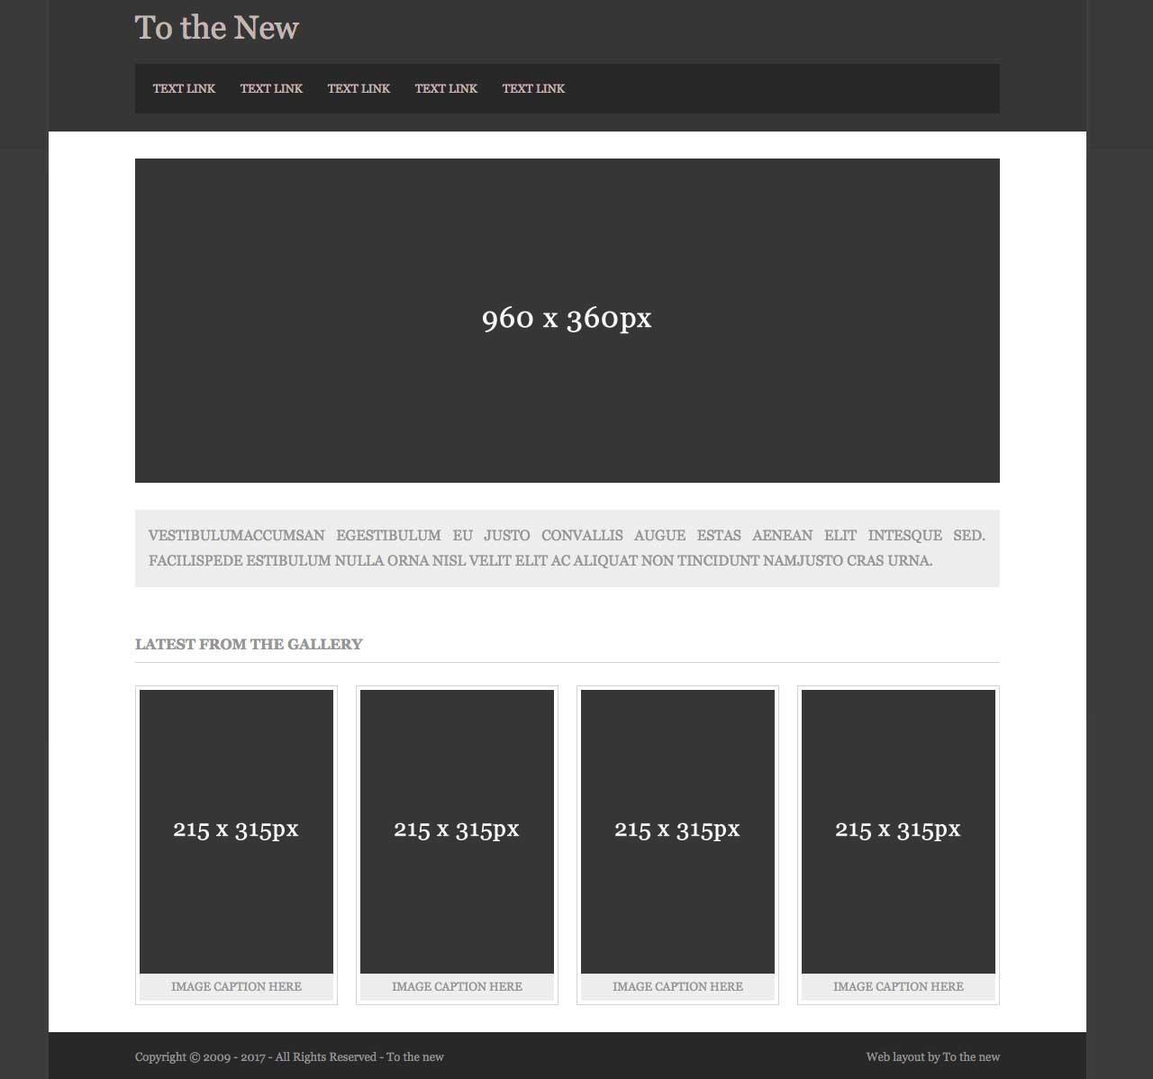

ANS:

<https://github.com/amanpatel-feen/Bootcamp-Training/tree/html-exercise>

**Create HTML for form.png (check resources, highest weightage for answers).**

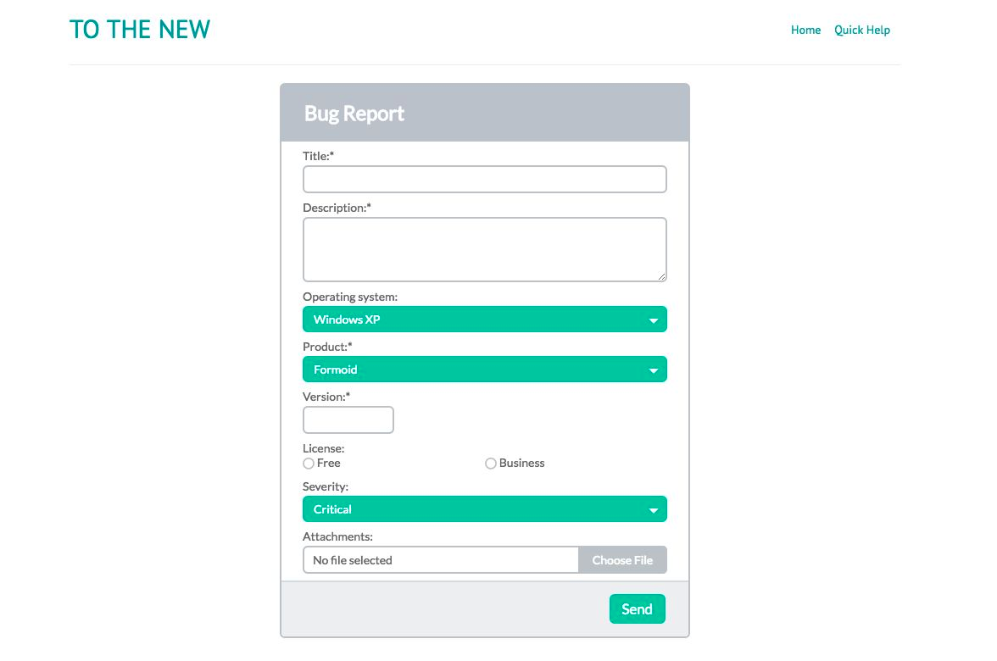ANS:

<https://github.com/amanpatel-feen/Bootcamp-Training/tree/html-exercise>